# Abstract

There is a current need for mechanical devices that assist an individual's voluntary movements. Such devices are being studied and developed but typically require an input from the patient. This input comes in the form of electromyographical (EMG) signals which are used to estimate human muscular contractile activity. This project focuses on assisting a patient who has difficulties eating by using the Maestro Mobile™ robotic arm to raise the patients' hand from table to mouth. The motion is activated by the patient's ability to contract some other muscle group on their body. Surface EMG sensors will be placed on the patient’s trapezius muscle group and will actively contract those muscles to produce a signal. Biopac software along with AcqKnowledge collect and process the raw data recorded from the contracting muscles by the Root Mean Square method. Once the data has been filtered using RMS, a Matlab program was developed to read the EMG signal amplitudes and determine a threshold amplitude that needs to be met in order to move the robotic assist arm up to the patient’s mouth. When the amplitude threshold of the muscle contraction is not met, the arm will lower to its starting position. This is accomplished by the patient relaxing the targeted muscle group.

# Table of Contents

Contents

Abstract 1

Table of Contents 2

Problem Statement 3

Background 5

Material and Methods 7

Equipment 7

Hardware Setup 9

Software Setup & Engineering Aspects 10

Statistical Analysis 14

Expected Outcomes & Anticipated Problems 16

Discussion and Future Capabilities 17

References 20

# Problem Statement

Individuals with amputated limbs, neuromuscular disorders, and various other conditions affecting voluntary motion face difficulties doing daily activities that are often taken for granted. Simple tasks such as eating, getting dressed, and brushing their teeth become almost impossible. Engineering and the field of medical devices are currently working towards improving the quality of life for these individuals and giving back some of their independence. Research has been done recently using surface EMG sensors. According to Mayo Clinic, Electromyography (or EMG) sensors are used to determine electric signals created by muscle activity and are used in diagnosis and medical device function. Data received by these sensors may be recorded, analyzed, and used in various algorithms. The use of these algorithms to control external robotic, or prosthetic, arms is a common use of the EMG results.

To focus on the assisting of upper limb motion, this study will use an assistive robotic arm that connects to the disabled limb. EMG sensors will be attached to muscles from another area of the body to record contractile activity. Motion of the assistive robotic arm will be determined by the signals received by the contracting muscle. An upper and lower threshold will be recorded based on the strength of the individual’s chosen muscle. An upper threshold will cause the limb to bring the arm in a superior direction, towards the mouth, and the lower threshold will cause the arm to lower in an inferior direction, towards a table. Programming the assistive arm to react to the muscle contraction in this way will allow the user to eat a meal independently.

# Background

Electromyographical (EMG) signals are used to monitor and quantify human muscular contractions. EMGs measure the amount of motor unit activity in the voltage/time domain. Surface EMG electrodes are placed on the skin where the muscle contraction will be measured. Surface EMG causes minimal patient discomfort but are restricted to superficial muscles and can be difficult to pinpoint exact muscles which are contracting.

Patient needs for prosthetic limbs are ever growing and changing. In a medical review by Julie Jacob, it was explained that there are 185,000 individuals in the United States that will have a limb amputated each year (2015). Options for individuals with prosthetic limbs has grown significantly and each advancement in the technology allows for more options and opportunities for the individual using the device. “People living with limb loss have a range of options, from noncomputerized leg prosthetics and cable-controlled prosthetic arms to myoelectric arms controlled by electrical signals generated from muscle contraction and leg prostheses equipped with microprocessors” (Jacob 2015). Muscle contraction that is evaluated may be located on what is left of the amputated limb or on a different muscle group. Some of these limbs include processors that read and convert electrical signals from muscle contraction or brain function.

As research progresses the abilities of the robotic arms follows. In some cases, patients are able to feel sensations from the arms or have more fluid movements that closely mimic the motion of a natural limb. A downfall of these advancements is the rise in cost for the limb. In some cases, the limb will have a price range of $6,000-$7,000 (Jacob 2015). Keeping in trend with most technology, as the limb abilities increase and become more complex the price will rise to reflect those abilities. This trend will reduce availability and accessibility for some devices among typical patients and users. Regardless, the ability of a prosthetic arm to improve the life of a patient remains the same.

In a review done by the Canadian Journal of Occupational Therapy, multiple types of robotic limbs were evaluated for their function and impact on the user. While the robotic arms evaluated may have been different, the criteria they were evaluated on was the same. Each arm was evaluated based on: self-care, leisure and productivity. In total, 36 studies were evaluated. This review evaluated the amount of studies and their quality for each category. Of the 36 studies, 58% looked at self-care, 22% looked at leisure, and 91% looked at productivity.

This distribution of the studies focus topics shows a flaw in research. The use of a prosthetic arm is to improve daily life and if the research is not focused on all aspects of the life then there will be flaws in the function of the device. Each of the 36 studies were also evaluated based on the quality of the study. The average quality for all studies was found to be 8.8/15 (Beaudoin 2019). A low-quality study will more than likely result in a low-quality product. Continuing research and striving to have higher quality research and studies will result in higher quality products and improve experience for the patient.

Powered exoskeletons have been developed to assist in human movements for those who have disabilities or other impairments. EMG recordings are used as driving signals for the assistive controller. A study was conducted at the BioRobotics Institute, Pisa, Italy, to understand the reaction of ten healthy patients to an EMG controlled assistive elbow exoskeleton. The goal of the study was to test the effectiveness of the controller in reducing the muscle efforts while also assessing the patient's capability of controlling movements when the assistance is active. The results of the study show that the healthy individuals adapt to the assistance provided by the exoskeleton and muscle efforts are reduced while still maintaining full control of their movements (Lenzi 2012). The exoskeleton does not alter the individual movements, but rather reads the EMG signal of the muscle contractility and algorithms process the motor control of the exoskeleton assist device.

# Material and Methods

This section explains the materials needed for the project both hardware and software as well as the step by step implementation to solve the problem statement. Furthermore, issues that may arise will be addressed with suggested techniques to overcome these challenges.

## Equipment

The following materials will be utilized in this project.

|  |  |
| --- | --- |
|  |  |
| Biopac software with lab manual | MP36 hardware |
|  |  |
| Electromyography (EMG) | MATLAB |
|  |  |
| AcqKnowledge 4.0 | Maestro Exoskeleton Arm Support with Power Assist, Talem Technologies |

The Maestro Mobile™ arm support (Talem Technologies LLC.) is a mechanical exoskeleton based on the SteadyCam™, developed by Garrett Brown for the motion picture industry, and intended to be mounted on a power wheelchair. For purposes of this project, a prototype table top mount and power assist module were proveded by Talem and added to the Maestro. The table top mount allows the device to be installed in close proximity to the prospective user. Talem’s power assist module robotically augments the performance of the passive mechanism and provides an interface for EMG activated motion. The power assist is actuated using Dynamixel XH540-V270 smart servos (Robotis US) which, when load balanced by the mechanical spring system of the Maestro, provide adequate torque to move an arm load of up to approximatly 8 kilograms over a range of 0.75 meters.

## Hardware Setup

Once the materials have been obtained the implementation procedure for the hardware connections can occur. The first step is to configure the hardware which is initiated by connecting the MP36 hardware to the computer via a USB, followed by connecting the EMG cables to channel 3. The next step is to connect the robotic arm which was developed by group member Blake Mathie (Talem Technologies LLC.) to the computer via USB. The last step for the hardware configuration is to attach the EMG electrode to the individual who will be contracting their shoulder to generate muscle fiber action potentials leading to a signal.

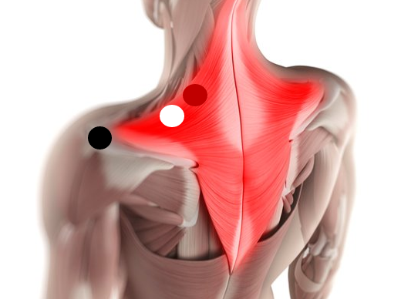

The left trapezius muscle was chosen to simulate arm motion; its EMG signals were recorded and analyzed. There are three main lead wires to attach to the left trapezius and its surrounding area of the individual. The first is the ground lead, which is black, that is placed on a bony location to prevent interfering electric pulses that may be caused by placing on other muscles. The power lead, which is red, is placed on the muscle the subject was flexing. Lastly, the white lead, the neutral lead is placed within close proximity to the red lead – preferably within one inch away and still located on the trapezius muscle. This concludes the hardware connection needed for the project, the next section will discuss the software and algorithm development.

## Software Setup & Engineering Aspects

The first step is to launch the biopac software and create a new experiment. To configure biopac turn off channel one and turn on channel 3, select tools and choose EMG 250hz with notch, keep channel sampling rate at 1000hz and output channel 3 control to on position. Next click start and scale vertically to have an optimized view of the signal to be generated. At this point the individual with the attached electrodes will be able to contract generating a signal in real time on the biopac interface as shown by **figure 1.**

Figure 1: biopac user interface of signals*.

Once biopac has been configured, save the generated action potentials to a MATLAB file and load the dataset to acknowledge 4.0 where applying the root mean square (RMS) with a sliding window of 30ms and 500ms can be applied. **Figure 2** shows the interface of raw data, RMS of 30ms, and RMS of 500ms.

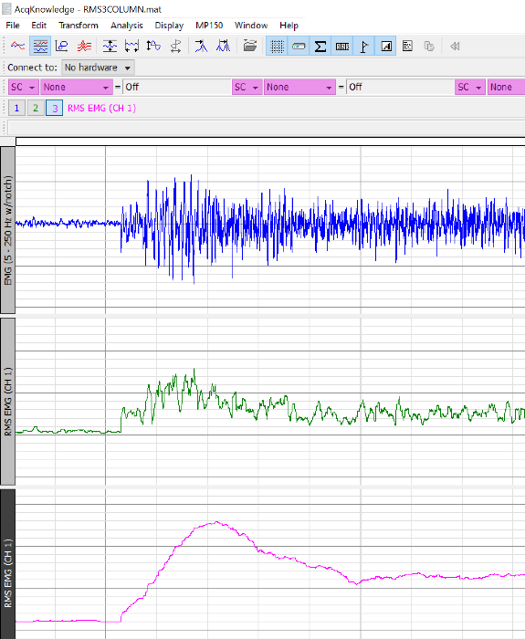

Figure 2: Top graph displays raw data, middle graph displays 30ms window, and bottom graph is 500ms.

The next step is to load the RMS data with sliding window of 500ms to MATLAB where an algorithm will be created to plot the RMS data and determine a suitable threshold to cause the robotic arm to move up or down. **Figure 3** displays the RMS sliding window at 500ms and is compared with the raw EMG data, it can be observed that RMS is successful in cleaning noise.

**Figure 3:** Root mean square with sliding window of 500 ms compared with raw EMG data. Left figure shows raw EMG data while right figure shows RMS.

Figure 3 shows that at 0.049mV a contraction is done by the test subject, when the data is reduced by a factor of 10. When the data rises above the threshold of 0.049 mV the individual is trying to feed themselves and thus wanting the robotic arm to move from the table where the food is to their respective mouth. This knowledge allows the algorithm to set a trigger causing the robotic arm to move upwards in increments of 5 step sizes. **Figure 6** displays the algorithm and will be discussed in detail.

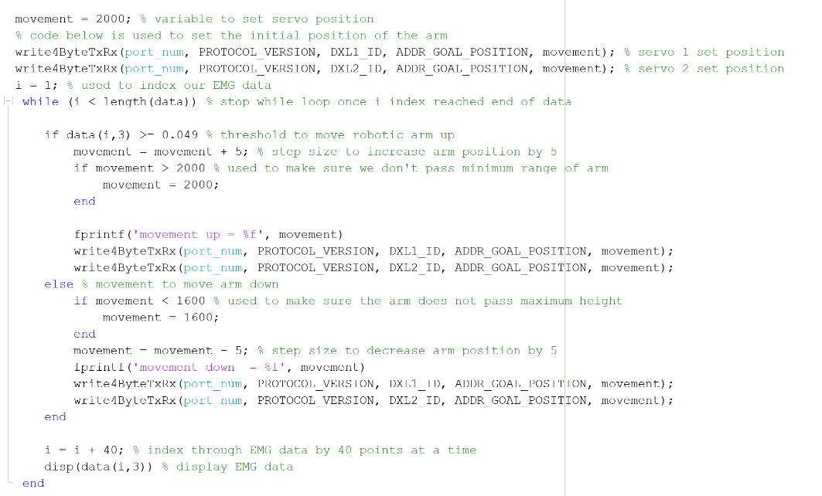

Figure 6: Algorithm for movement of an exoskeleton.

The first step is to initialize a starting position of the arm, the proper position should start at the mouth of the subject which is at a servo position of 2000, therefore movement is initialized to 2000. Next an index variable will be created to iterate through the EMG RMS data and a while loop is implemented to continuously loop through the data and stop once the final data point is reached. The basic operation of this algorithm is the if else statement where a threshold is used to move the arm up or down, in this dataset the robotic arm will move down when the data value that i reaches is less than 0.049 and move up when it passes it. Nested if statements are further implemented to prevent the robotic arm to pass the minimum and maximum positions the robotic arm may reach.

Overall, the setup of both hardware and software can be summarized by the flow chart below, if one wished to recreate this experiment then following the below flow chart will allow them to understand the big picture of the experimental setup.

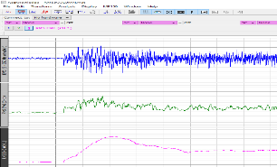

* The picture in figure 1 is an example of what biopac user interface looks like, it is not EMG data obtained in this dataset.

## Statistical Analysis

The average EMG activity for the left trapezius is 0.43 mV, according to a joint study done by the American University of Beiruit and Louisiana State University (2015). As the leads for the EMG data acquisition for this project were connected to the left trapezius, the values obtained were compared to a similar value for analysis. In this case the value was 0.49mV. Three individuals volunteered to participate in this study. Due to the decision to use three individuals, the statistical analysis being used for this data was a One Way – ANOVA test. A One Way – ANOVA test is used to compare sample means of two or more groups. In this case, the sample data was taken by the EMG readings of three individuals, representing the three groups.

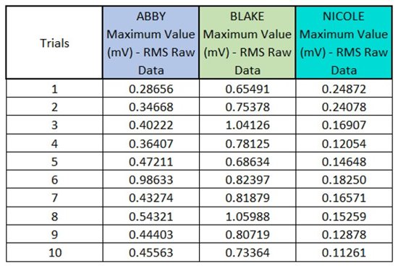

Using the Data Analysis capabilities in Excel, the One Way – ANOVA was calculated. When a One Way – ANOVA test is completed the values obtained are compared to each other and it is determined whether or not the mean values compared are statistically significant. The threshold chosen, 0.49mV, should be reached in order to cause the robotic assistive arm to move. In the case of the Raw Data, for all three individuals, it was determined that the findings were statistically significant and that the arm would move. However, the mean values were not all above the 0.49mV threshold requirement for all three individuals. This is representative that although, the average EMG value was found there may be individuals that perform muscle contractions at a different mV threshold.

As shown by the raw data received from the EMG results, the first individual did not reach the average EMG mV reading needed for movement for all but two contractions. Similar results were found in the third individual, where none of the contractions were made at or above the threshold value. These low ratings can be seen as a cause in the statistical error and insignificance. Low mV ratings can be contributed to the individual being used for the trials, their muscle strength, or how the leads were attached to the individual. If any part of the set up there may be unrealistic results recorded. 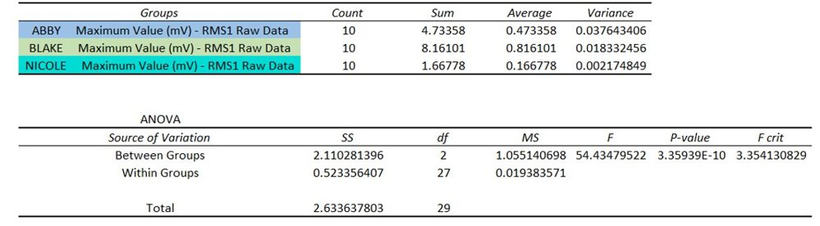

## Expected Outcomes & Anticipated Problems

The outcome of the project is to move the robotic arm up or down based on the trigger point of 0.049 as mentioned in the software setup & engineering aspects section. The major issue that is presented is the level of noise that will be generated during contractions, since the electrodes are adhered to skin there is a chance that they may shift or fall off especially if the individual testing out the project has oily skin. The best way to overcome this issue is to use the root mean square (rms) as shown in equation 1

(1)

The purpose of the root mean square is its ability to produce EMG signals that are much easier to analysis as compared to the raw EMG data, thus creating less noise which in turn will allow the algorithm to process accurate muscle contractions leading to the correct position of the robotic arm.

# Discussion and Future Capabilities

The project was successfully completed with both software and hardware integrating together, this project can pave the way for future developments of integrating efficient algorithms to control exoskeleton movements allowing individuals with disabilities to live a normal life. One extension to improve the complexity of this project which in turn can increase the practicality of the project is to allow for data to be used in real time, for example, allowing a disabled person to adhere electrodes to areas of muscle movement will generate an action potential signal, the signal will be loaded into biopac to generate the data, this data will be loaded into MATLAB to create a RMS algorithm from scratch to clean the noise of the signal, and finally the RMS signal will be fed into the servo movement functions to move the exoskeleton arm based on a certain threshold.

Creating a real time system will have its major issue in terms of generalizability, meaning if the algorithm is expected to work with multiple users then each user will have their own specific threshold which needs to be continuously evaluated to determine. This in turn will lead to other issues in terms of using statistical evaluation between each subject with different disabilities which places electrodes in different limbs, it would be difficult to compare the strengths of say a trapezius and a bicep contraction because they both generate different magnitudes of action potentials. The best way to overcome this challenge is to simply normalize the dataset of all subjects to allow for each data value to be between 0 and 1, this prevents one dataset from dominating the statistical method used to compare each muscle group. **Equation 2** shows the formula for normalizing data also known as feature scaling.

(2)

The final way to improve on this project is to introduce a promising field of computer science/ mathematics known as machine learning. The purpose of machine learning is to create mathematical models that will allow for accurate predictions, intelligent thinking, and discover patterns in the dataset. There are 3 main categories of machine learning, which include supervised learning, unsupervised learning, and reinforcement learning. Supervised learning trains a model based on labeled data, an example is a dataset that has each patient labeled with having cancer or not, while unsupervised learning is when there are no labels and each sample is clustered together based on similarities. Reinforcement learning is the technique that could potentially be used in this project, for example, suppose that instead of an individual wearing electrodes around their house, they could move a robotic arm to feed them without having to be connected to the robot. This is achieved by using reinforcement learning algorithms that will learn from the training data generated in this project for that specific individual, each time the robot makes a mistake such as moving up when it is supposed to move down, it will increase the loss function while be rewarded when it does the task correctly. Furthermore, adding speech recognition and natural language processing will move the exoskeleton based on the wearers voice. The mathematical and algorithm analysis of machine is beyond the scope of this project so it will not be discussed in detail, the purpose of mentioning these algorithms is to show that they can aid in the development of exoskeleton and intelligent robotics in patient care.

Fundamentally the project was carried out successfully with the major challenge of noisy signals filtered out with root mean square analysis, future improvements will include real time data processing, generalizable algorithms so different subjects can use the exoskeleton on different muscle groups, and the ability to use machine learning algorithms to create a full automated robotic arm to aid in health care.

# References

Al-Qaisi, S., & Aghazadeh, F. (2015). Electromyography Analysis: Comparison of Maximum Voluntary Contraction Methods for Anterior Deltoid and Trapezius Muscles. *Procedia Manufacturing*, *3*, 4578–4583. doi: 10.1016/j.promfg.2015.07.475

Beaudoin, M., Lettre, J., Routhier, F., Archambault, P. S., Lemay, M., & Gélinas, I. (2018). Impacts of robotic arm use on individuals with upper extremity disabilities: A scoping review. *Canadian Journal of Occupational Therapy*, *85*(5), 397–407. doi: 10.1177/0008417418820878

Electromyography (EMG). (2019, May 21). Retrieved February 3, 2020, from https://www.mayoclinic.org/tests-procedures/emg/about/pac-20393913

Jacob JA. Advanced Prosthetics Provide More Functional Limbs. *JAMA.* 2015;313(22):2209–2211. doi:10.1001/jama.2015.5144

Lenzi, T., et al. “Intention-Based EMG Control for Powered Exoskeletons.” IEEE Transactions on Biomedical Engineering, vol. 59, no. 8, 2012, pp. 2180–2190., doi:10.1109/tbme.2012.2198821.